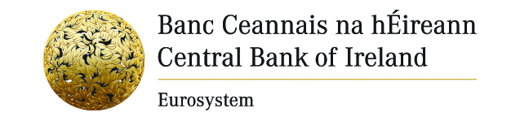

Press Release 9 November 2011

EMBARGOED: Not for publication before 9 November 2011

Central Bank of Ireland Issues Warning on Investment Firm

The Central Bank of Ireland today (Wednesday 9 November 2011) published a warning notice on First Standard Management Limited (Ireland, Switzerland and Hong Kong) The firm is not authorised as an investment firm in Ireland and has been claiming or holding itself out to be an investment firm in the State. The notice is published today in Irish daily newspapers under the European Communities (Markets in Financial Instruments) Regulations 2007.

It is a criminal offence for an investment firm to operate in Ireland unless it has an authorisation from the Central Bank of Ireland. Clients of unauthorised firms are not eligible for compensation from the Investor Compensation Scheme.

Any person wishing to contact the Central Bank of Ireland with information regarding such firms may telephone (01) 224 4000. This line is also available to the public to check if an investment firm is authorised. Since obtaining the necessary legal powers in August 1998, 87 warnings naming 161 firms have been issued. A list of all warning notices issued to date is available on the website www.centralbank.ie

Ends

Further information: Press Office: (0)1 224 6299

