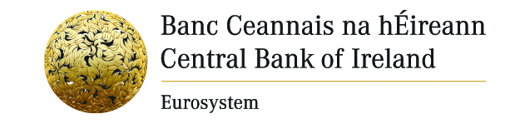

Press Release 18 September 2012
Central Bank of Ireland Issues Warning on Investment Firm

The Central Bank today (18 September 2012) published the name of an unauthorised investment firm. Yang Financial (China) has been offering investment services to members of the Irish public and is not authorised as an investment firm in Ireland.

A list of unauthorised firms published to date is available on the Central Bank website.

It is a criminal offence for an investment firm to operate in Ireland unless it has an authorisation from the Central Bank of Ireland. Consumers should be aware that, if they deal with an investment firm which is not authorised, they are not eligible for compensation from the Investor Compensation Scheme.

Any person wishing to contact the Central Bank of Ireland with information regarding such firms may telephone (01) 224 4000. This line is also available to the public to check if an investment firm is authorised. Since obtaining the necessary legal powers in August 1998, the names of 192 unauthorised firms have been published by the Central Bank.

Ends

Media queries: Press Office: (0)1 224 6299

Notes to editors

The name of the above firm is published under the European Communities (Markets in Financial Instruments) Regulations 2007.

